
Y. Suresh Kumar - 19241193
CSA1043
Software Engineering for Industry

LAB OBSERVATION

Experiment 1: Create a Kanban Board
Title: Create a Kanban Board to Visualize the Tasks.
Aim: To create a Kanban board to visualize tasks and simulate the workflow by moving tasks across columns.
Software Required: Jira or Trello.
Procedure:
- Set up the Kanban board with three columns: "To Do," "In-Progress," and "Done".
- Add at least 5 sample tasks to the "To Do" column (e.g., "Research algorithms," "Write unit tests").
- Move tasks from "To Do" to "In-Progress" to indicate work has started.
- Update task details as work progresses.
- Move completed tasks to the "Done" column.
Input: A list of project tasks (e.g., Research computer vision algorithms, Prepare slides).
Output: A visual board showing the status of tasks across the workflow.
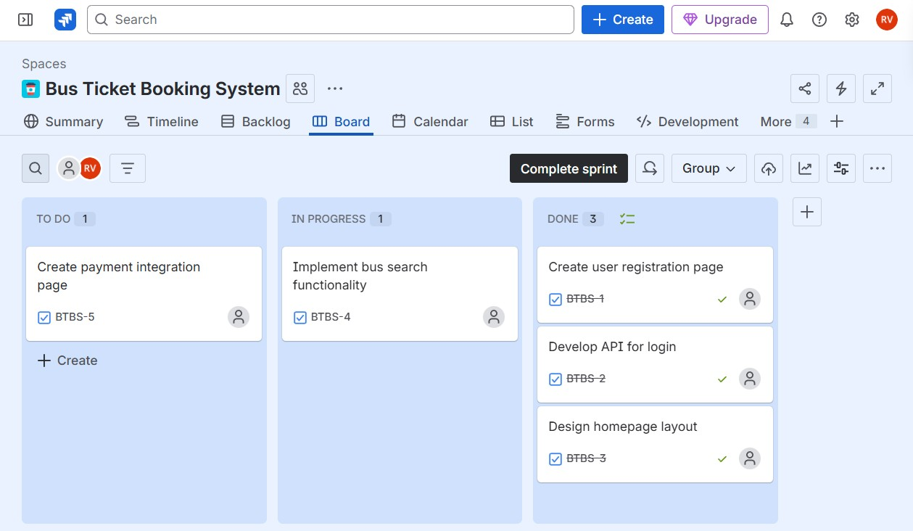

Result: The Kanban board was successfully created, and the workflow was simulated.
Experiment 2: Bus Ticket Booking Prototype
Title: Sketch a Simple Prototype of a Bus Ticket Booking System using Figma Tool.
Aim: To create a prototype for a Bus Ticket Booking System using Figma.
Software Required: Figma.
Procedure:
- Create a new file in Figma and select the Frame tool to create screens (Home, Search, Booking Details, Payment).
- Design the Home Screen with a header, navigation buttons, and a search box.
- Design the Search Page with input fields for "From," "To," and "Date," and a list of bus options.
- Design the Booking Details Page showing a summary and passenger input fields.
- Design the Payment Page with payment methods and a submit button.
- Switch to Prototype Mode and link the screens using interactions (e.g., "On Click," "Navigate To").
Input: Design requirements for a booking system (buttons, text fields, headers).
Output: An interactive prototype of the Bus Ticket Booking System.
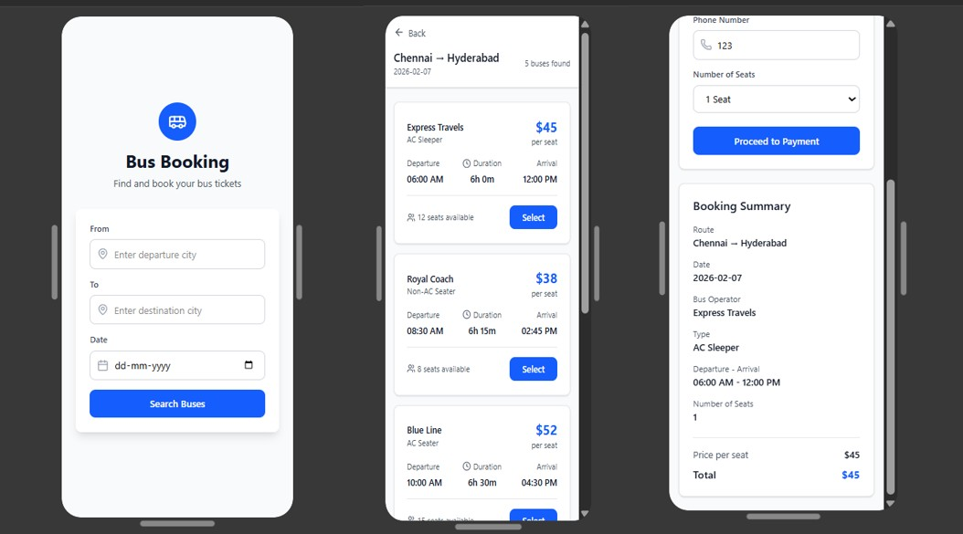
Result: The prototype was successfully designed and simulated in Figma.

Experiment 3: E-Commerce App Prototype
Title: Prototype for E-Commerce Mobile App Interface.
Aim: To create a prototype using Figma to discuss with stakeholders and resolve conflicting views on the user interface.
Software Required: Figma.
Procedure:
- Identify the conflicting stakeholder views regarding the UI design.
- Create frames for the E-Commerce app (e.g., Product List, Cart, Checkout) in Figma.
- Implement UI elements that address the requirements.
- Share the prototype with stakeholders to gather feedback and approval.
Input: Conflicting UI requirements from stakeholders.
Output: A shareable Figma prototype link for stakeholder review.
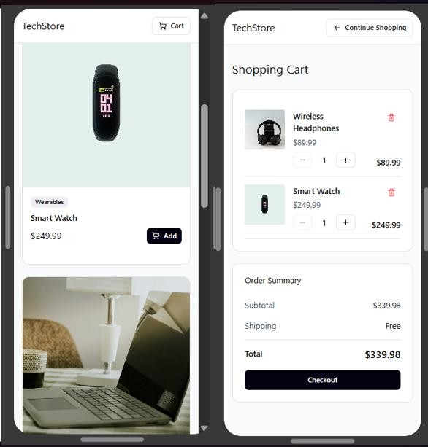
Result: The E-Commerce app prototype was created for stakeholder feedback.
Experiment 4: Scrum Project in Jira
Title: Create a Scrum Project in Jira.
Aim: To demonstrate backlogs using Scrum on Jira and show the sprint board process.
Software Required: Jira.
Procedure:
- Create a new project in Jira using the "Scrum Software Development" template.
- Add a backlog with at least 5 items (e.g., "Create user registration page," "Develop API").
- Prioritize the backlog by dragging critical items to the top.
- Create a 1-week sprint and move prioritized items into it.
- Start the sprint and capture a screenshot of the board.
- Move items to "Done" and capture a screenshot at the end of the sprint.
Input: 5 backlog items/user stories.
Output: Screenshots of the Sprint board at the start and end of the sprint.
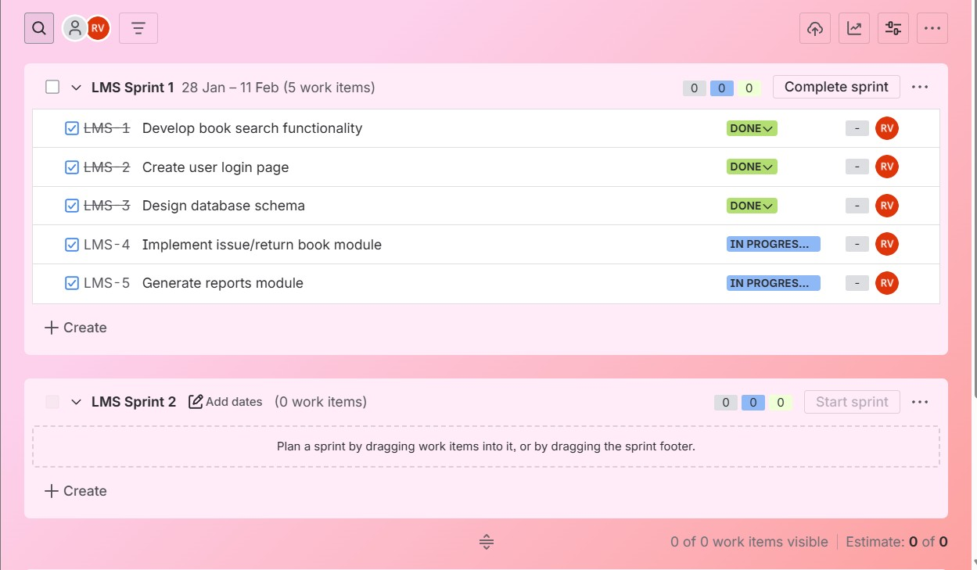
Result: The Scrum project was created, and the sprint lifecycle was successfully demonstrated.

Experiment 5: Requirements Categorization (MoSCoW)
Title: Library Management System Requirements Categorization.
Aim: To categorize requirements for a Library Management System using the MoSCoW Method.
Software Required: Google Sheet or Excel.
Procedure:
- List the given requirements (e.g., Search books, QR code scanning, Chatbot).
- Analyze each requirement based on impact on users and feasibility.
- Categorize each as Must-Have, Should-Have, Could-Have, or Won’t-Have.
- Enter the data into a spreadsheet.
Input: List of 10 specific requirements for a Library Management System.
Output: A Google Sheet or Excel file with categorized requirements.
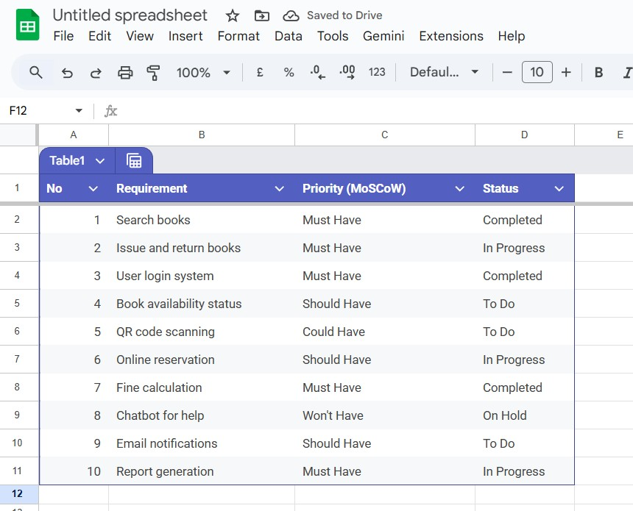
Result: The requirements were successfully prioritized using the MoSCoW method.

Experiment 6: Link Jira and Confluence
Title: Link Jira tasks with Confluence for Library Management System.
Aim: To streamline task tracking by linking Jira tasks to a Confluence page.
Software Required: Jira & Confluence.
Procedure:
- Create a new page in Confluence titled "Library Management System Project Overview".
- Use the Jira macro to search for and embed at least 5 Jira issues (e.g., "Develop book search functionality").
- Configure the macro to display the status of the issues (To Do, In Progress, Done).
- Add a progress bar to visually track the completion percentage of the sprint tasks.
Input: Active Jira tasks related to the Library Management System.
Output: A screenshot of the Confluence page showing embedded Jira tasks and a progress bar.
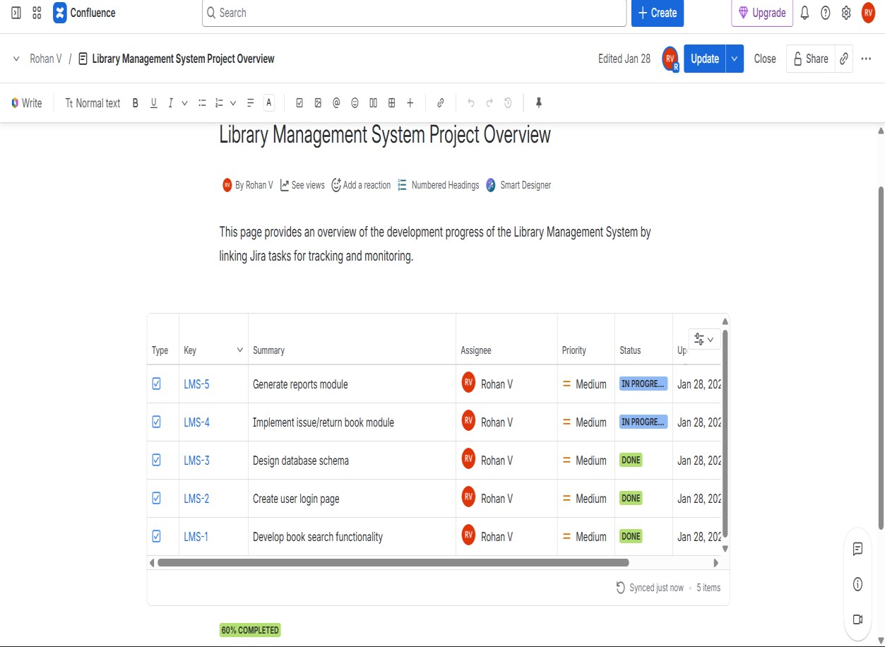
Result: Jira tasks were successfully linked and visualized in Confluence.

Experiment 7: Task Management System Prioritization
Title: MoSCoW and Kano Models for Task Management System.
Aim: To prioritize requirements for a Task Management System using MoSCoW and Kano models.
Software Required: Jira.
Procedure:
- Input requirements into Jira: User Login, Task Creation, Prioritization, Progress Tracking.
- Apply the MoSCoW model to categorize features (Must, Should, Could, Won't).
- Apply the Kano model to categorize features (Basic, Performance, Excitement).
Input: Four specific requirements for a Task Management System.
Output: Prioritized requirements list in Jira.
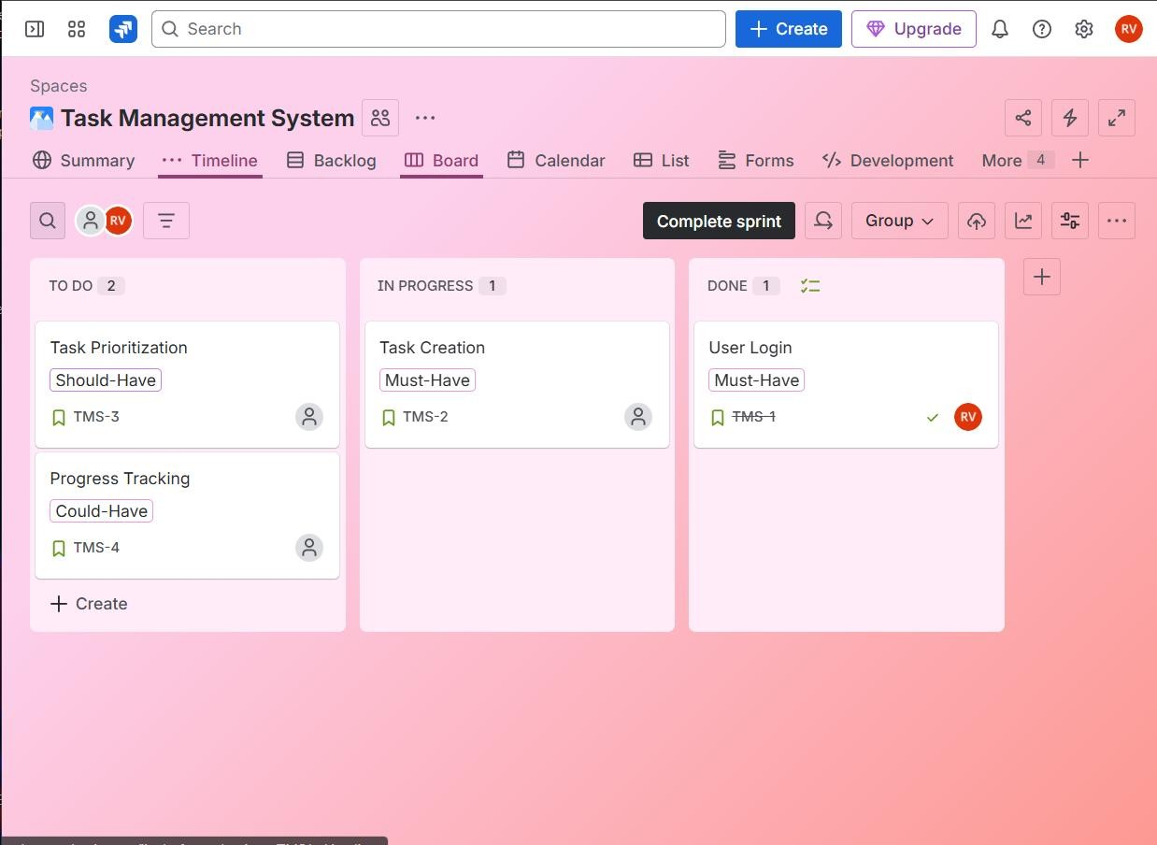
Result: Requirements were successfully prioritized using MoSCoW and Kano models.

Experiment 8: Online Learning Platform Prioritization
Title: Requirement Prioritization for Online Learning Platform.
Aim: To categorize and prioritize requirements for an Online Learning Platform.
Software Required: Jira.
Procedure:
- List requirements: Course Enrolment, Video Streaming, Quizzes, Dashboard, Forums, Certificates.
- Use Jira to categorize these requirements using MoSCoW techniques.
- Use Jira to categorize these requirements using Kano techniques.
Input: List of 6 functionalities for the platform.
Output: A Jira project with requirements categorized by priority.
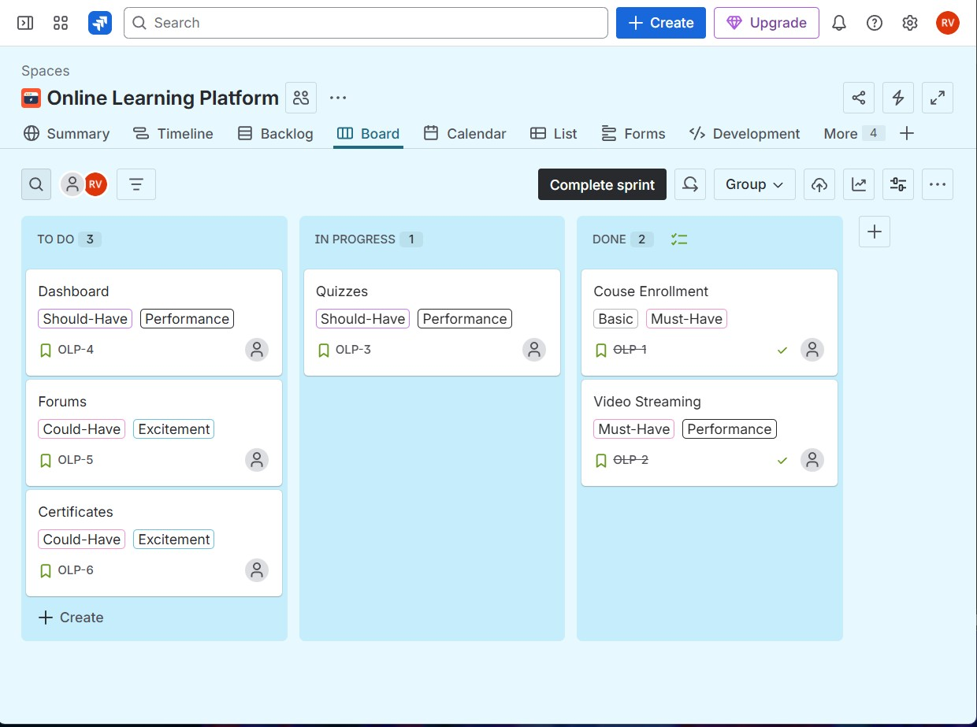
Result: The requirements were successfully prioritized in Jira.

Experiment 9: Collaborative Git Workflow
Title: Work collaboratively in Git/GitHub using the fork-and-pull request workflow.
Aim: To demonstrate collaboration by forking, modifying, and submitting a pull request.
Software Required: Git/GitHub.
Procedure:
- Fork an existing public repository on GitHub.
- Clone the forked repository to the local machine.
- Create a new branch for a feature.
- Make modifications (e.g., update README) and commit changes.
- Push the branch to GitHub and create a pull request.
- Review feedback, make additional commits if necessary, and merge.
Input: A public GitHub repository URL.
Output: A merged pull request link and summary of changes.
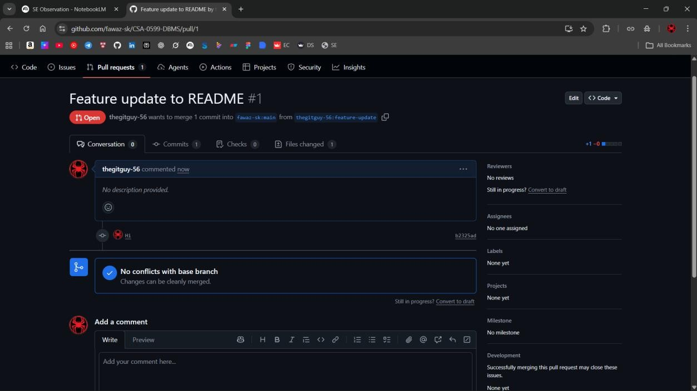
Result: The fork-and-pull request workflow was successfully executed.

Experiment 10: Git Branching and Merge Conflicts
Title: Demonstrate how to work with Git branches and resolve merge conflicts.
Aim: To simulate team collaboration conflicts and resolve them manually.
Software Required: Git/GitHub.
Procedure:
- Clone a shared repository and create a new branch.
- Make changes to a file and commit them.
- Push changes to the remote repository.
- Pull the latest changes from the main branch and merge main into the feature branch.
- Resolve any file conflicts manually, commit the resolution, and push the branch.
Input: A shared repository and conflicting code edits.
Output: A summary of steps and conflict resolution.
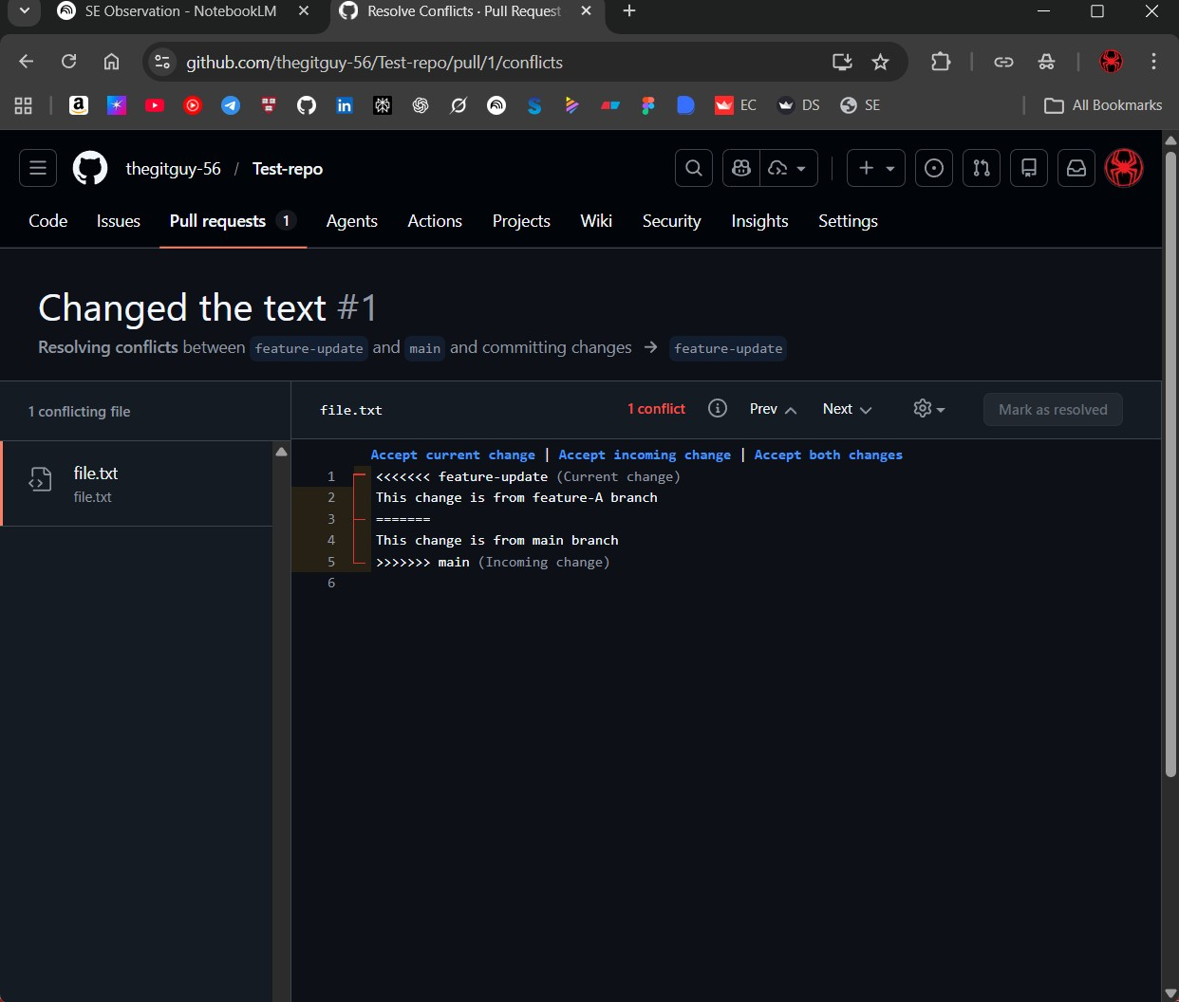
Result: Merge conflicts were identified and resolved successfully.
Experiment 11: Containerize Static Website
Title: Create a Static Website and Containerize, Build & Serve it using Docker.
Aim: To create a simple static website and serve it using a Docker container with Nginx.
Software Required: Docker.
Procedure:
- Create an index.html file with basic HTML content.
- Create a Dockerfile that uses the Nginx image and copies the HTML file to the html directory.
- Build the Docker image using docker build.
- Run the container using docker run mapping the ports.
- Access the website via a web browser.
Input: index.html file and Dockerfile.
Output: A static website accessible via localhost.
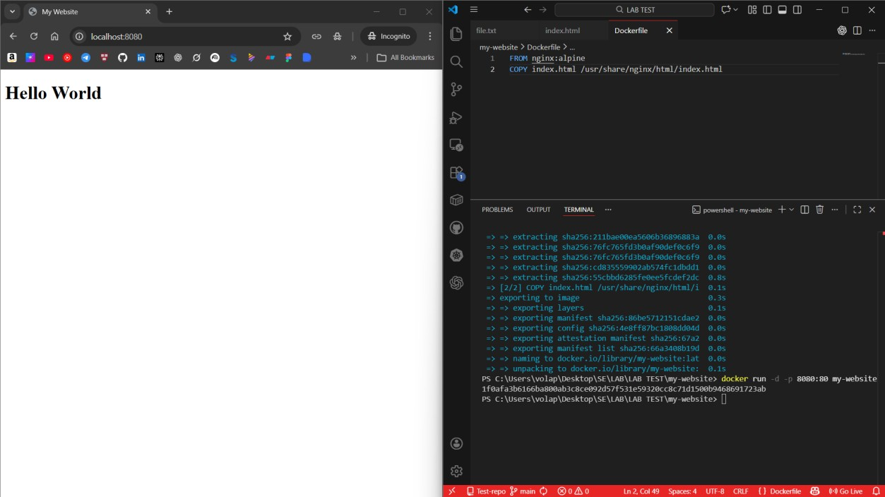
Result: The website was successfully containerized and served using Docker.

Experiment 12: Flask API with Docker & Kubernetes
Title: Create a Simple Python Flask API, Containerize, and Deploy using Kubernetes.
Aim: To develop an API, containerize it, and deploy it using Kubernetes manifests.
Software Required: Docker & Kubernetes.
Procedure:
- Write a Python file (app.py) for a simple Flask API.
- Create a Dockerfile to containerize the Flask app.
- Build the image and push it to Docker Hub.
- Create Kubernetes manifests: Deployment.yaml and Service.yaml.
- Apply the manifests to the cluster and access the API via NodePort.
Input: Python application code and Kubernetes YAML files.
Output: A running API deployed on a Kubernetes cluster.
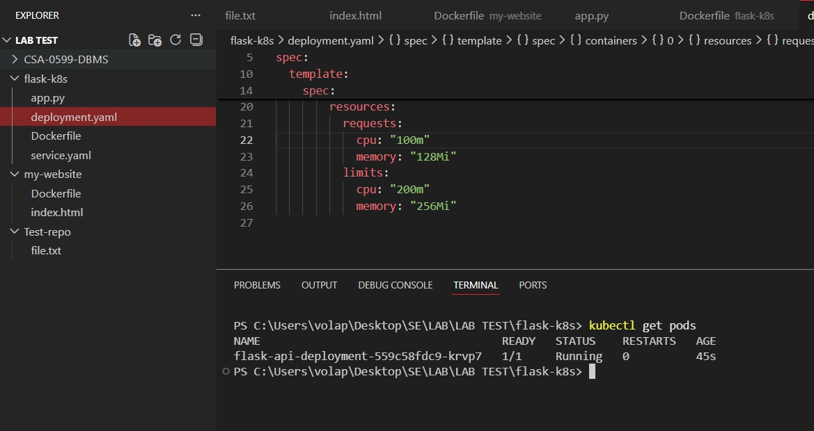
Result: The Flask API was successfully containerized and deployed.

Experiment 13: CI/CD with Jenkins
Title: Set up a CI/CD pipeline to automate building, testing, and deployment.
Aim: To automate the application lifecycle using a Jenkins pipeline.
Software Required: Docker (and implied Jenkins based on context).
Procedure:
- Create a Dockerfile for a sample application.
- Write a Jenkinsfile to define the pipeline stages (Build, Test, Deploy).
- Configure Jenkins to trigger builds automatically upon code commits or pull requests.
- Run the pipeline to build the container and deploy to a cloud platform.
Input: Source code, Dockerfile, and Jenkinsfile.
Output: Automated build and deployment logs.
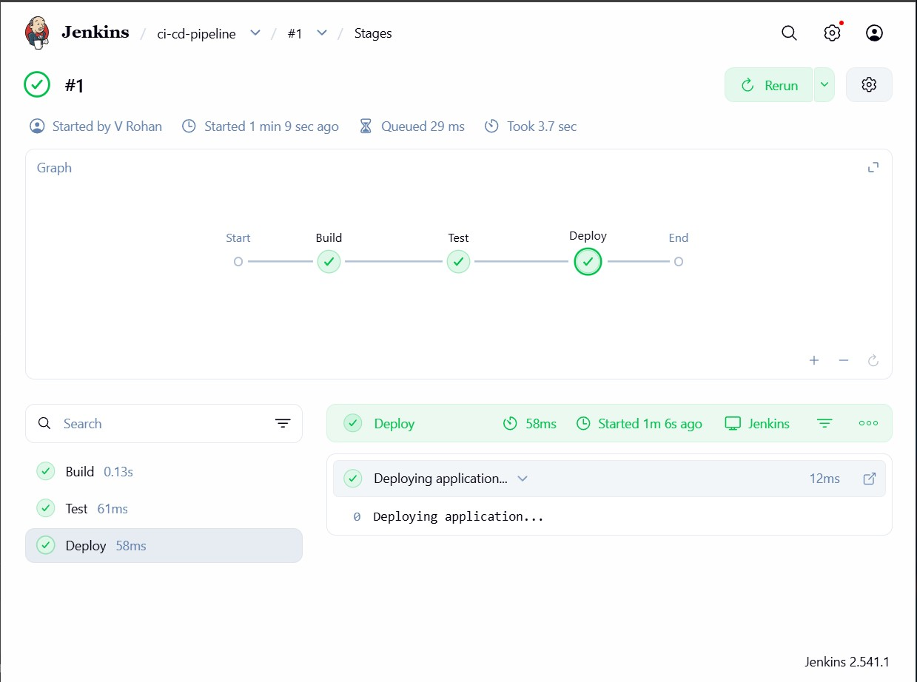
Result: The CI/CD pipeline successfully automated the build and deployment process.

Experiment 14: Continuous Deployment with GitHub Actions
Title: Implement Continuous Deployment using GitHub Actions.
Aim: To deploy a Dockerized application automatically using GitHub Actions.
Software Required: Docker.
Procedure:
- Push a Dockerized application to a GitHub repository.
- Create a GitHub Actions workflow YAML file.
- Configure the workflow to build and push the image to a registry (Docker Hub/GitHub Container Registry).
- Add steps to deploy the image to a cloud platform (e.g., AWS ECS, Azure, GKE).
- Test by pushing code changes.
Input: GitHub repository with application code and Workflow YAML.
Output: Automatic deployment to the cloud upon code push.
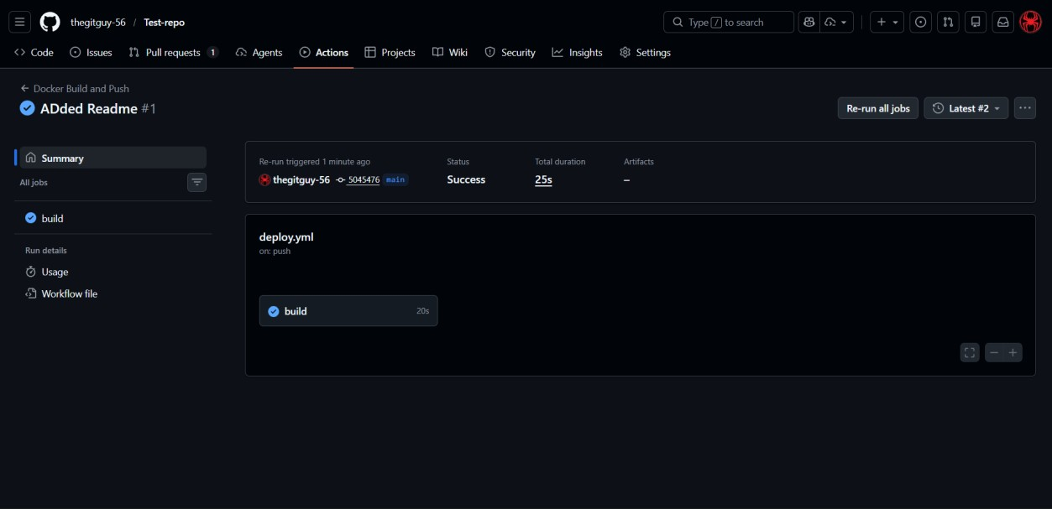
Result: Continuous deployment was successfully implemented via GitHub Actions.

Experiment 15: Team Repository Version Control
Title: Create a GitHub Repository and Implement Version Control.
Aim: To manage a team project using branches, code reviews, and conflict resolution.
Software Required: Git/GitHub.
Procedure:
- Set up a repository for a team project.
- Create separate branches for individual modules.
- Merge branches using pull requests after code reviews.
- Resolve conflicts during merging and document the workflow in README.md.
Input: Team code modules.
Output: A repository link with merged branches and documentation.
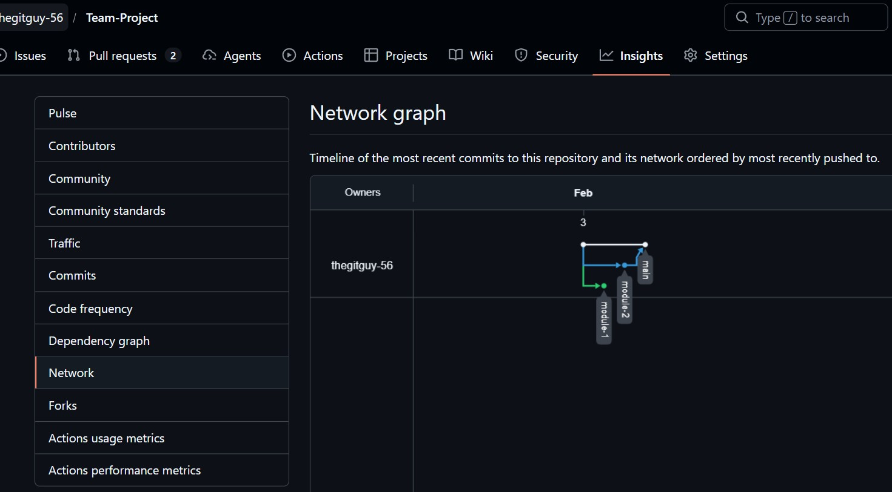
Result: The team successfully collaborated using version control best practices.

Experiment 16: Containerize Flask "To-Do" App
Title: Containerize a Python Flask Application Using Docker.
Aim: To create and test a Docker container for a "To-Do" list application.
Software Required: Docker, Flask.
Procedure:
- Write a Flask application for a "To-Do" list.
- Create a Dockerfile for the application.
- Build and run the container locally.
- Test functionality inside the container.
- Push the image to Docker Hub.
Input: Python Flask code and Dockerfile.
Output: Screenshots of testing results and the Dockerfile.
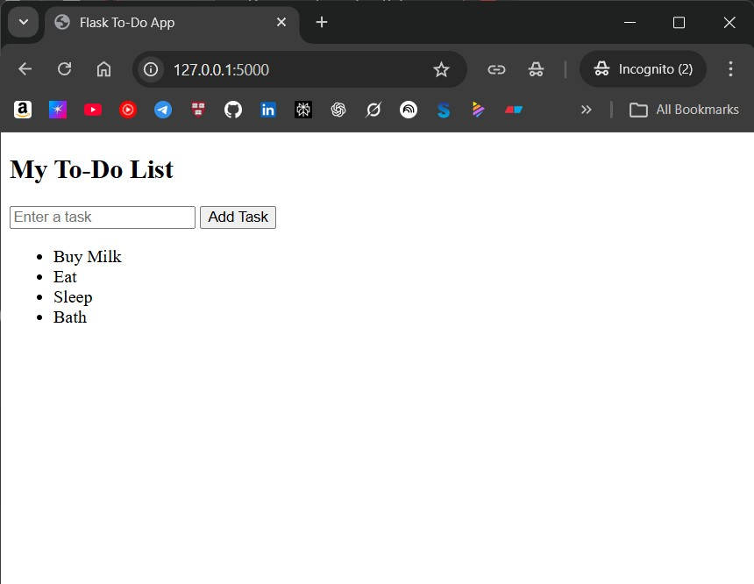
Result: The "To-Do" application was successfully containerized and tested.

Experiment 17: Push and Pull Docker Images Title: Push and Pull Docker Images Using Docker Hub.
Aim: To demonstrate sharing Docker images via Docker Hub.
Software Required: Docker Hub, Docker CLI.
Procedure:
- Create a Docker image for a static HTML website.
- Tag the image and push it to Docker Hub.
- Pull the image from Docker Hub on a different machine.
- Run the pulled image.
Input: Local Docker image.
Output: Docker commands used and screenshots of the process.
Result: The image was successfully pushed to and pulled from Docker Hub.

Experiment 18: Multi-Container App on Kubernetes
Title: Deploy a Multi-Container Application Using Kubernetes.
Aim: To deploy a complex application with frontend, backend, and database using Kubernetes.
Software Required: Docker, Kubernetes.
Procedure:
- Create a multi-container app (Frontend, Backend, Database).
- Define Kubernetes YAML files for Deployments and Services.
- Deploy using kubectl commands.
- Monitor pods and scale the frontend container.
Input: Multi-container application code and Kubernetes manifests.
Output: YAML files and screenshots of the Kubernetes dashboard.
Result: The multi-container application was successfully deployed and scaled.

Experiment 19: CI/CD for Flask with GitHub Actions
Title: Create a CI/CD Pipeline Using GitHub Actions.
Aim: To automate testing and deployment for a Flask application using GitHub Actions.
Software Required: GitHub Actions, Docker.
Procedure:
- Set up a GitHub repository for a containerized Flask app.
- Define a GitHub Actions workflow file.
- Add steps to build, test, and push images to Docker Hub.
- Add a step to deploy to a cloud platform (e.g., Heroku/AWS).
Input: Flask application and github/workflows file.
Output: Workflow file and deployment link.

Result: The CI/CD pipeline successfully built, tested, and deployed the application.

Experiment 20: Git README Updates
Title: Initialize Repository and Update README.
Aim: To practice basic Git commands: init, clone, edit, and push.
Software Required: Git/GitHub.
Procedure:
- Create a GitHub repository and initialize it with a README.md.
- Clone the repository to the local machine.
- Edit the README.md file (add description).
- Stage, commit, and push changes back to GitHub.
Input: Project description text.
Output: Updated README.md on GitHub.
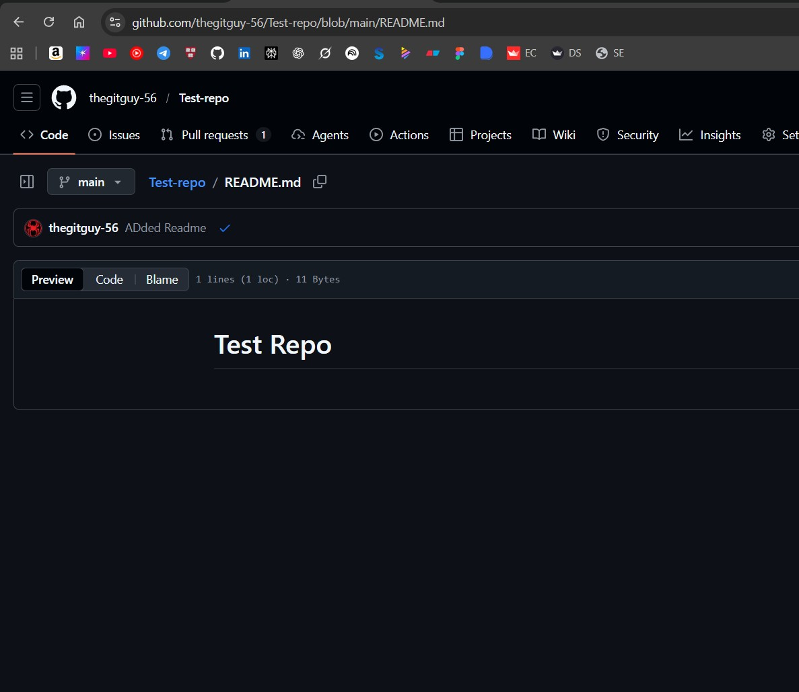
Result: The repository was successfully updated and synchronized.

Experiment 21: Edit Cloned Repository
Title: Clone an existing GitHub repository and make a small change.
Aim: To modify files in a cloned public repository.
Software Required: Git/GitHub.
Procedure:
- Choose a public repository and clone it using git clone.
- Navigate into the directory and open a file.
- Make a small edit (e.g., fix a typo).
- Save the changes.
Input: Public repository URL.
Output: Modified local file.
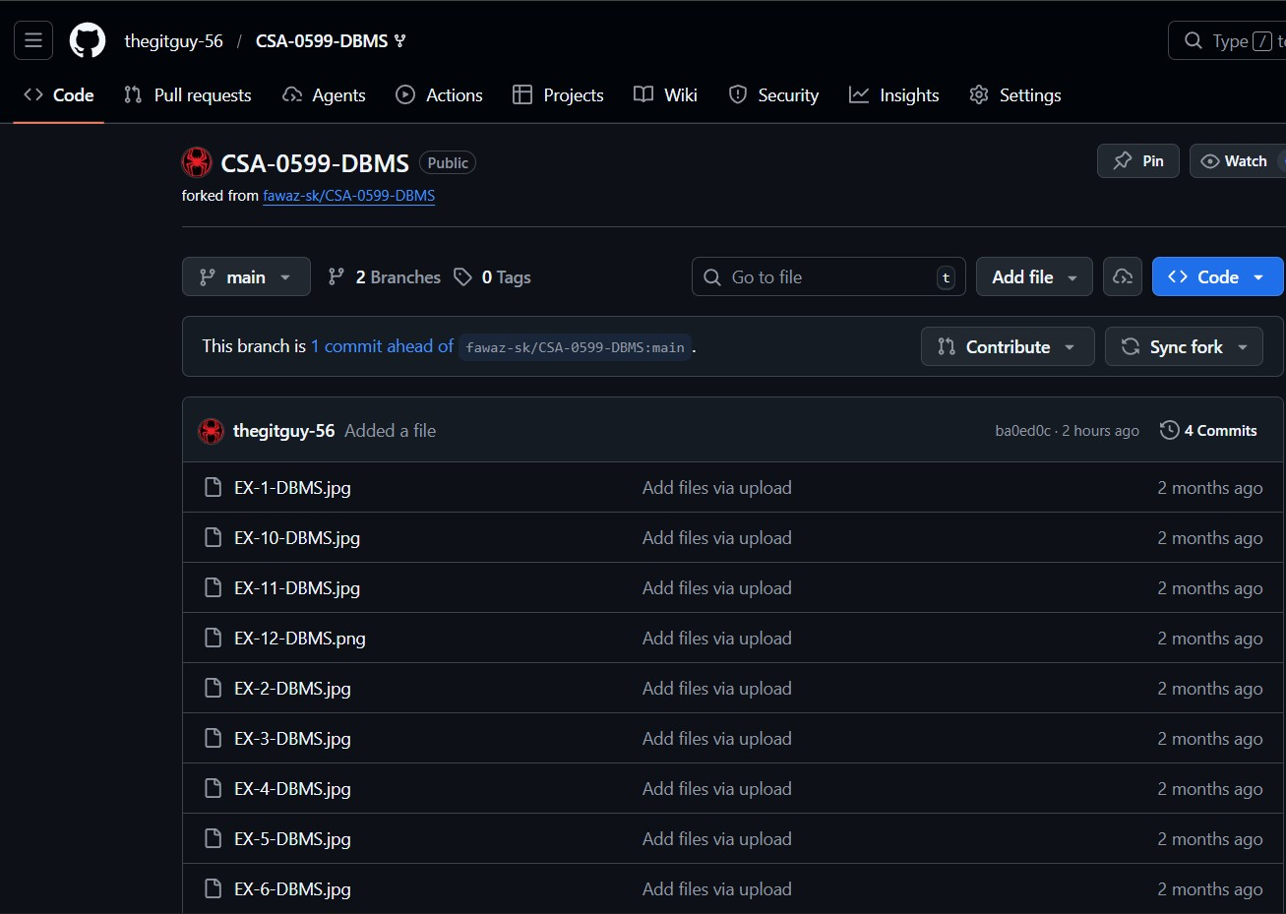
The repository was cloned and a file was successfully modified locally.
Experiment 22: Commit and Push Changes
Title: Commit changes locally and push them to GitHub.
Aim: To record changes and upload them to the remote repository.
Software Required: Git/GitHub.
Procedure:
- Clone a repository and modify a file (continuation of Exp 21).
- Stage changes using git add.
- Commit changes using git commit -m.
- Push changes using git push.
Input: Modified local files.
Output: Updated remote repository on GitHub.
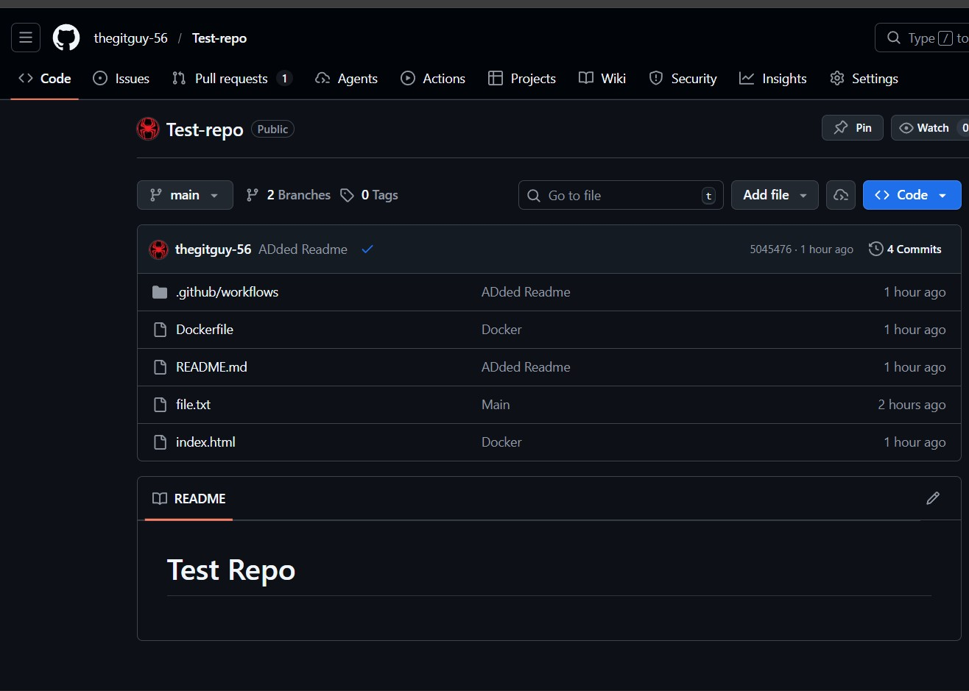
Local changes were successfully committed and pushed.
Experiment 23: Git Pull
Title: Pull the latest changes from GitHub.
Aim: To update the local repository with changes made by a collaborator.
Software Required: Git/GitHub.
Procedure:
- Clone a repository.
- Have a collaborator (or simulate one) push a change to the GitHub repository.
- Use git pull origin main to fetch changes.
- Verify the changes appear in the local repository.
Input: Remote repository with new commits.
Output: Updated local repository matching the remote.

The local repository was successfully updated using git pull.

Experiment 24: Feature Branch and Pull Request
Title: Create a new branch and Pull Request for a Login feature.
Aim: To implement a feature in a separate branch and merge it via Pull Request.
Software Required: Git/GitHub.
Procedure:
- Create a new branch feature-login.
- Add a login.py file with a function.
- Commit and push the branch to GitHub.
- Create a pull request from feature-login to main and merge it.
Input: Python code for login function.
Output: Merged code in the main branch on GitHub.
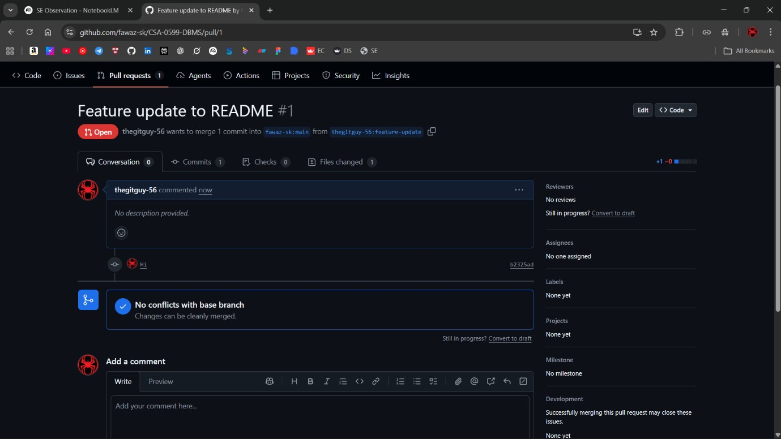
Result: The feature branch was successfully merged via a Pull Request.

Experiment 25: Fork and Feature Implementation
Title: Fetch changes, create branch, and implement feature in forked repo.
Aim: To contribute to a project using fork, branch, and pull request without affecting existing code.
Software Required: Git/GitHub.
Procedure:
- Fork a repository.
- Clone the repository locally.
- Create a new branch for a feature.
- Implement changes and push to the forked repository.
- Submit a pull request to the original repository.
Input: Forked repository URL and new feature code.
Output: Pull request submitted to the original repository.

Result: The feature was successfully implemented and submitted via Pull Request.

